

Mamasaheb Mohol College Paud Road, Pune-38

Department of Computer Science

Savitribai Phule Pune University,Pune 2021-2022

A

PROJECT REPORT ON

**Online Retail Store**

Submitted In Partial Fulfillment Of The Requirement For The Award Of The Degree OF

MSc(Comp.Sci) Sem- III

**Guided by**:- **Submitted by**:-

Pratik Chorghe

Rasika Dalwale



Mamasaheb Mohol College Paud Road, Pune-38

Department of Computer Science

Shape

**CERTIFICATE**

This is to certify that Mr./ Miss of MSc(Computer Science) Sem-III has satisfactorily completed project work entitled

prescribed by Savitribai Phule Pune University, Pune during

academic year 2021-22 and this report represents his/her bonafide work.

Project Guide HOD

Internal Examiner External Examiner

**Index**

| Sr. No. | Title | Page No. |
| --- | --- | --- |
| 1. | Abstract | 4 |
| 2. | Introduction | 5 |
| 3. | Problem Definition | 6 |
| 4. | Objective and Goals | 7 |
| 5. | Scope and Limitations | 8 |
| 6. | Feasibility Study | **9** |
| 7. | Fact Finding Techniques | 11 |
|  | **System analysis** |  |
| 8. | Existing systems | 12 |
| 9. | Requirement analysis - Functional requirements, performance requirements, security requirements etc. | 13 |
|  | **System Design** |  |
| 10. | System Model: UML diagrams | 14 |
| 11. | Data Model  User interfaces(Screen shots) | 23 |
|  | **Testing** |  |
| 12. | Test Plan, Black Box Testing or Data Validation Test Cases, White Box Testing or Functional Validation Test cases and results | 35 |
| 13. | **Conclusion and Recommendations** | 36 |
| 14. | **Future Scope** | 37 |
| 15. | **Bibliography and References** | 38 |

**Abstract**

Before pandemic we face war situation with china and we decided as country to be self - dependent as country but it still for to be. After pandamic all business are shifted online system and our local business get scratch by it more. So we are bringing both views in same. To developed an indigenous platform to boost self dependence and promote local business.

With the help of this web app, the consumer & business owner are able to perform all operations they can do with a general e-commerce application or an ONDC website. Being a B2C web app, this platform also helps business owners to manage their businesses internally by enhancing their B2B operational capabilities. This web app can grant badges to sellers, based on customer reviews to make shopping easier for them.

**Introduction**

India is a developing country and Information Technology is playing important role in development of the country. By ecommerce platform, we mean buying and selling of products over electronic systems such as the Internet.

In India, we are availed multiple ways to pay our bills online or trade online. Additionally, there are numerous online ecommerce platforms for Groceries, Fashion, Food, etc. But we still lack of a dedicated online ecommerce platform for disposable and housekeeping items. Online Retail Shop Management System (ORSMS) fulfills this need of *crores* of business owners who are struggling because of lack of ‘Ease of Doing Business’ in their area of expertise or marketing.

The Indian household cleaners market reached a value of USD 6,163 Million in 2021. Looking forward, it is expected that the market to reach USD 18,757 Million by 2027, exhibiting a CAGR of 19.63% during 2022-2027.

Additionally, India’s disposable food packaging market size reached approximately USD 22.00 Billion in 2022. Looking forward, it is expected that the market to reach 25.65 Billion Units by 2028, exhibiting a growth rate (CAGR) of 2.50% during 2023-2028.

This implies that both markets have reached the valuation of approximately USD 28,163 Million in the years 2021-2022, despite the country was facing serious economic crisis raised due to Covid-19 and nation-wide lockdown. If an industry can make such huge progress without any dedicated, online ecommerce platform, one can imagine its potential, if it is supported by an online platform.

This system allows users to register their details in the system, and allows them to use

this system after logging in successfully. This system provides a faster way than the

traditional system. This site can be accessed with proper login details.

# **Problem Definition**

In India, we have online eCommerce platforms for nearly every business/commercial need, being a regular consumer of those services; I should not necessarily explain the importance of syncing an online eCommerce platform with any business.

Considering the damage caused to Indian economic growth because of the pandemic and nationwide lockdown situations, it is necessary for all kinds of local businesses in the country to be synced with an online eCommerce platform, so that the business, its market, its ecosystem, and an overall economy of the nation can play the role of Phoenix.

Online Retail Shop Management System or an ORSMS, a dedicated, online eCommerce platform exclusively made for the B2B as well as B2C transactions of single Housekeeping and Disposable Items Business, can manage the operations of such businesses through a single application, to save time and resources of the business owners and administrators. This platform provides a user-friendly GUI, a robust and secure database management system, and the most secure payment operations.

Seller/s can post their product/s and everyone can buy them at a price mentioned by a seller. This platform will be controlled by a single admin, who is authorized for managing all products and sellers. This feature can also internally regulate the operations performed during the online business. We can guarantee that this platform will help businesses to save their time and resources to achieve more gains and success.

**Objective And Goals**

Currently, business owners owning businesses of housekeeping products and/or disposable items products, have to do business in a typical way, with a lot of paperwork and record maintenance. No business owners can analyze their sales data properly, which leads to a lack of data management aspect in this industry.

This system allows them to keep a track record of the stock available, as well as keep the track record of sellers, who are associated with them. When the product is Out of Stock, the user will get to know the same when they login to the system, in the respective section. This feature can save the time and resources of a seller as well as an admin.

This system provides a facility to classify the products under a specific ‘Category’, which will help track the sales of particular kinds of products so that one can analyze and plan the business strategy accordingly. Additionally, this system provides an Admin Dashboard, where he/she can track sales, and overall statistics of all transactions performed in a system.

# 

**Scope**

* The proposed system can overcome all the problems and limitations of the current system to run the business of housekeeping and disposable items’ products.
* An admin, a seller, or a customer can operate their respective roles from anywhere and at any time through a laptop or mobile phone, instead of physically going to shops or business centers, or warehouses, which can save resources, time, and effort of everyone involved in this business.
* A customer has the option to make payment using online mode or Cash on Delivery.
* Quick ordering and quick shipping can save the time of an organization, which will eventually lead to the eternal growth of the business.
* Being an online shopping website, the platform will get more exposure through Google AdSense and other digital marketing as well as PR tools.
* A customer can cancel the order at any time.

**Limitations**

* The size of the database increases day-by-day, increasing the load on the database backup and data maintenance activity.
* Training for simple computer operations is necessary for the users working on the system.
* Cyber-crimes are increasing day by day, so advanced data security is needed to implement.
* It is concluded that there would be a need for an independent platform where the orders in specific areas (based on pin-code) are listed. These orders can be allocated to respective delivery persons in the same area. Huge shipping cost expenditure to deliver those products to their end users**.**

**Feasibility Study**

The main objective of the feasibility study is to test the Technical, Operational and Economical feasibility for adding new modules and debugging old running systems. There are aspects in the feasibility study portion of the preliminary investigation:

* Technical Feasibility
* Operation Feasibility
* Economic Feasibility

**1. Technical Feasibility**

The technical issue usually raised during the feasibility stage of the investigation includes the following:

* Does the necessary technology exist to do what is suggested?
* Will the proposed system provide adequate response to inquiries, regardless of the number or location of users?
* Can the system be upgraded if developed?
* Are there technical guarantees of accuracy, reliability, ease of access and data security?

The software and hardware requirements for the development of this project are not many and are already available in-house at any business center or are available as free as open source. The work for the project is done with the current equipment and existing software technology.

**2. Operational Feasibility**

Proposed project is beneficial only if it can be turned into an information system. That will meet the organization’s operating requirements. Operational feasibility aspects of the project are to be taken as an important part of the project implementation. Some of the important issues raised are to test the operational feasibility of a project includes the following: -

* Is there sufficient support for the management from the users?
* Will the system be used and work properly if it is being developed and implemented?
* Will there be any resistance from the user that will undermine the possible application benefits?

**3. Economic Feasibility**

A system can be developed technically and that will be used if installed must still be a good investment for the organization. In the economic feasibility, the development cost in creating the system is evaluated against the ultimate benefit derived from the new systems. Financial benefits must equal or exceed the costs.

The system is economically feasible. It does not require any additional hardware or paid software. Since the interface for this system is developed using the existing resources and technologies available at any business infrastructure, there is nominal expenditure and economic feasibility for certain.

**Fact Finding Techniques**

Fact-finding techniques are a process of collection of data and information based on techniques that contain a sampling of existing documents, research, observation, questionnaires, interviews, prototyping, and joint requirements planning. System analysts use suitable fact-finding techniques to develop and implement the current existing system. Collecting required facts are very important to apply tools in the System Development Life Cycle because tools cannot be used efficiently and effectively without proper extracting from facts.

Fact-finding techniques are used in the early stage of the System Development Life Cycle including the system analysis phase, design, and post-implementation review. Facts included in any information system can be tested based on three steps: data facts used to create useful information, process- functions to perform the objectives, and interface- designs to interact with users.

**Seven common fact-finding techniques are:**

§ A sampling of existing documentation, forms, and databases

§ Research and Site visits

§ Observation of the work enviro

§ Questionnaires

§ Interviews

§ Prototyping

§ Joint requirements planning

# 

# **Existing System and need for new System**

As we have described in the ‘Problem Definition’ section, for each Indian startup or middle-aged business, there is a need for a dedicated online eCommerce platform to boost their overall performance to get maximum profit.

We should start this from the smaller case or a smaller user of the system, that is a local business owner, who is a retailer, but want to build a network through sellers. It would be beneficial for that business owner as well as the sellers, who will join him/her on this platform.

Currently, business owners owning businesses of housekeeping products and/or disposable items products, have to do business in a typical way, with a lot of paperwork and record maintenance. No business owners can analyze their sales data properly, which leads to a lack of data management aspect in this industry.

This system allows them to keep a track record of the stock available, as well as keep the track record of sellers, who are associated with them. When the product is Out of Stock, the user will get to know the same when they login to the system, in the respective section. This feature can save the time and resources of a seller as well as an admin.

This system provides a facility to classify the products under a specific ‘Category’, which will help track the sales of particular kinds of products so that one can analyze and plan

the business strategy accordingly. Additionally, this system provides an Admin Dashboard, where he/she can track sales, and overall statistics of all transactions performed in a system.

**Requirement Analysis**

Requirement analysis produces in the specification of software operational characteristics:

It indicates software interface with other system elements. It establishes constraints that should be accomplished.

Requirement analysis provides information, function & behavior that can be translated into architectural interface & component level design.

This translation is performed during construction of an analysis model.

It includes:

* Decision and addition of all important functions which are maintained in the requirements.
* Decision and addition of all important functions which are not maintained in the requirements, but it is essential to build.
* Definitions of all interfaces of the software to be developed

* **Software Requirements:**

| Operating System/s: | Windows/Linux |
| --- | --- |
| Browsers: | Mozilla Firefox, Google Chrome |
| Front-end: | ReactJS, HTML/CSS, JavaScript, Bootstrap |
| Back-end: | MongoDB |
| Platform: | NodeJS |

* **Hardware Requirements:**

| Processor: | Pentium III or any advanced processor |
| --- | --- |
| RAM: | 256MB or more |
| Hard Disk Space: | 40GB or more |

**UML DIAGRAMS**

**Entity-Relationship Diagram**

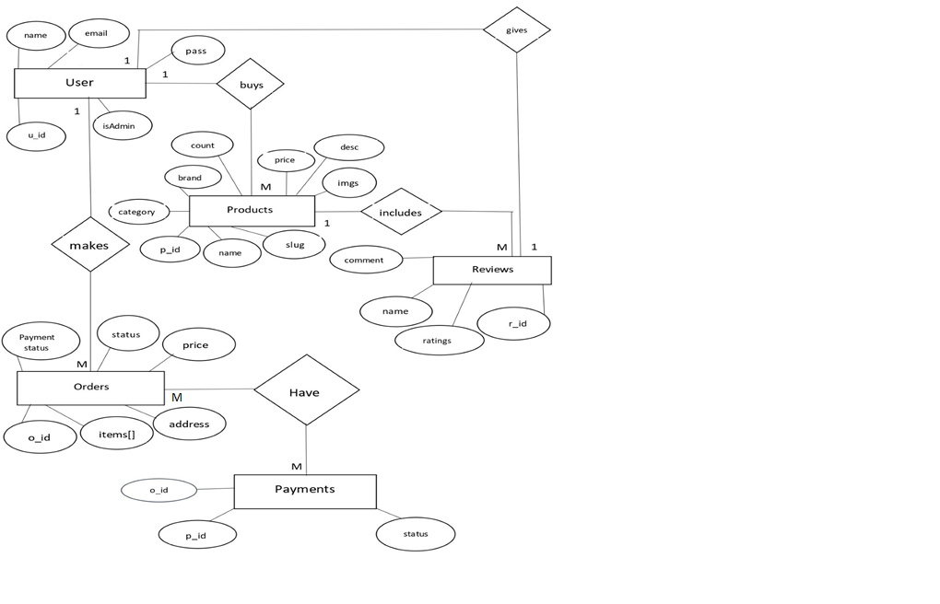

**Use-Case Diagrams**

**Use Case 1:**

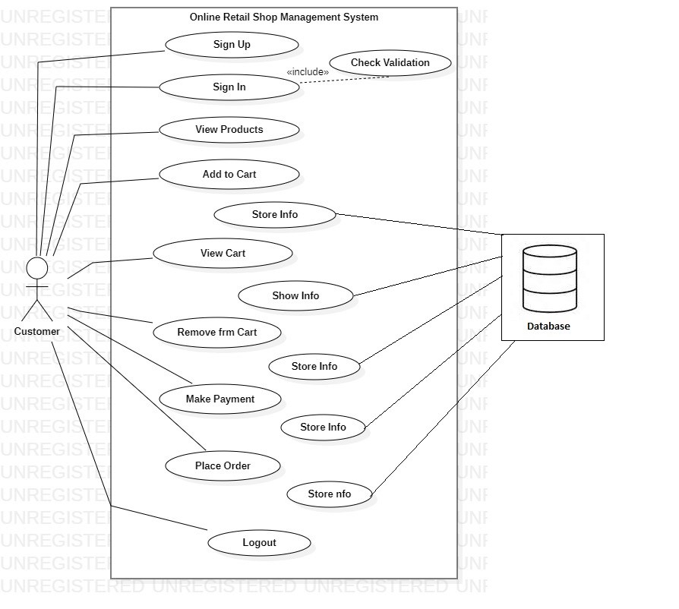

**Text Box**

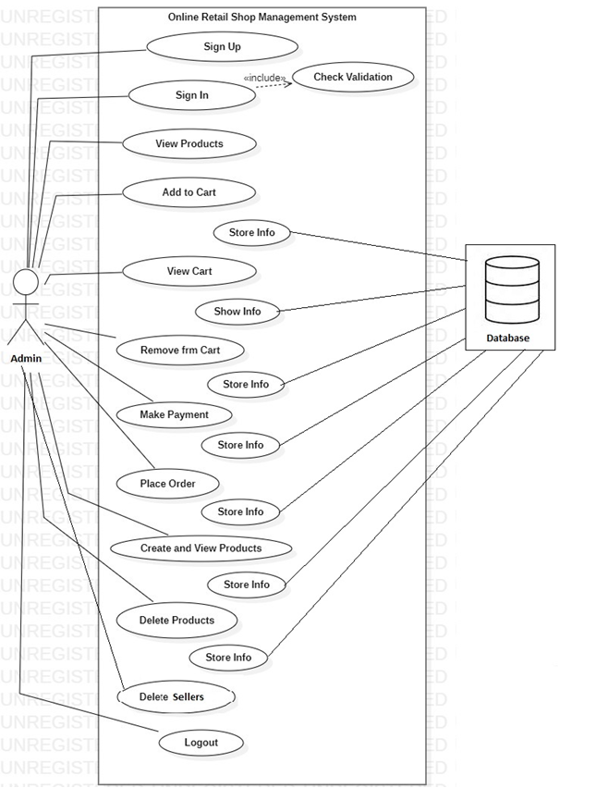

**Text Box**

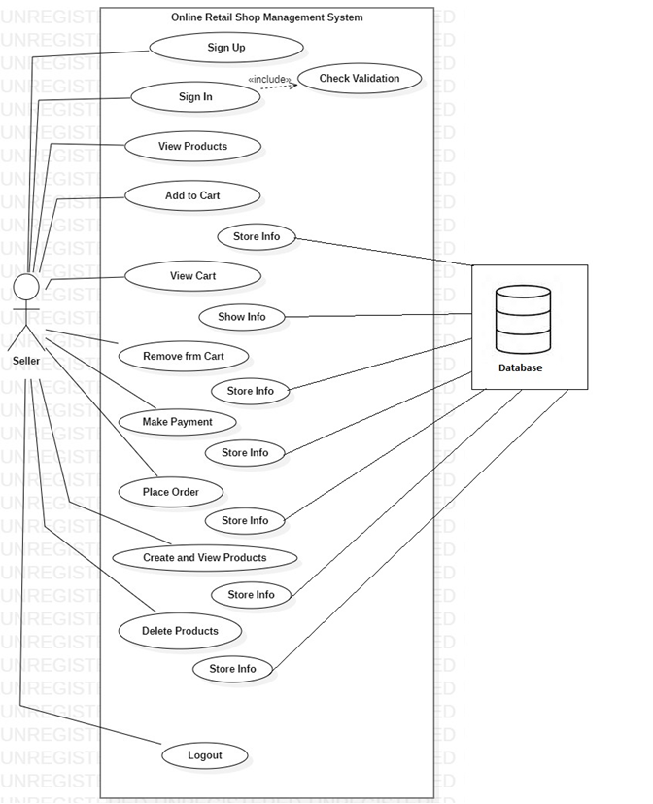

**Class Diagram**

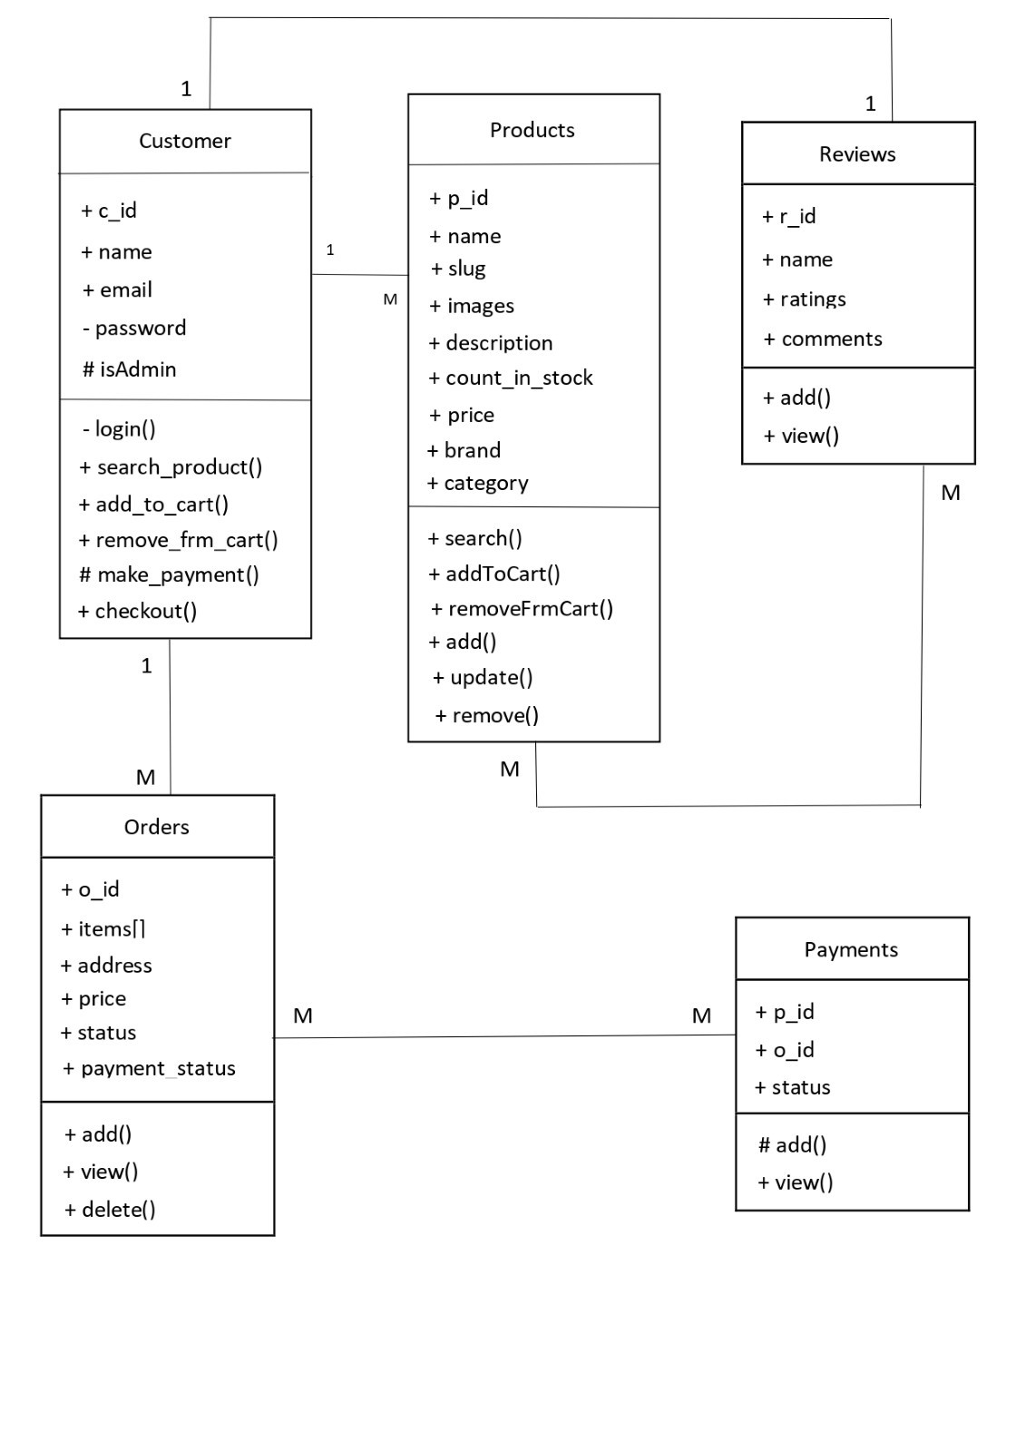

**Sequence Diagram**

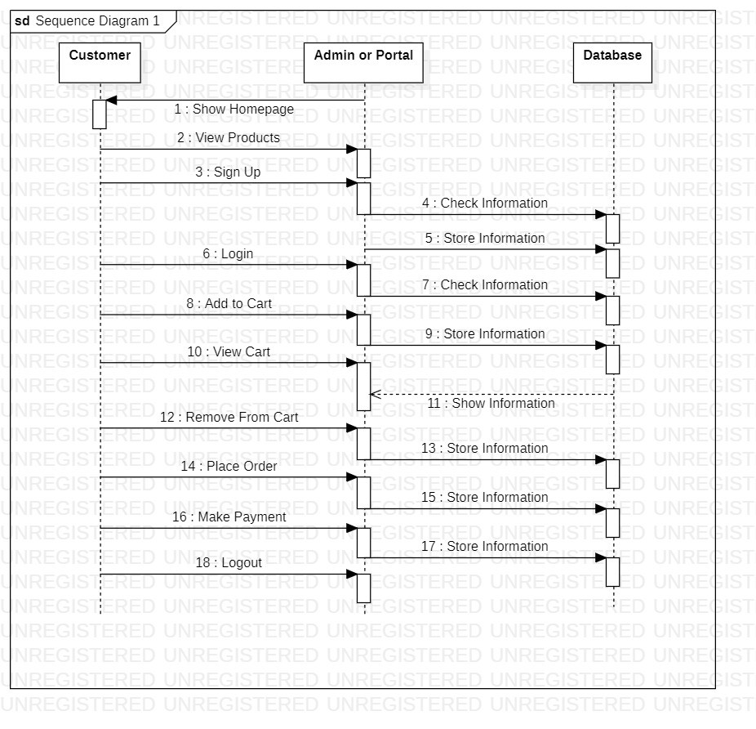

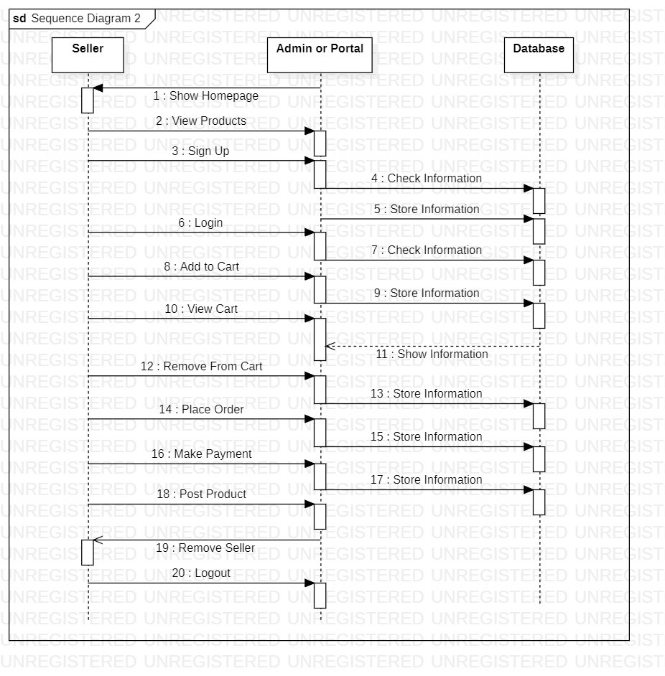

**Activity Diagram**

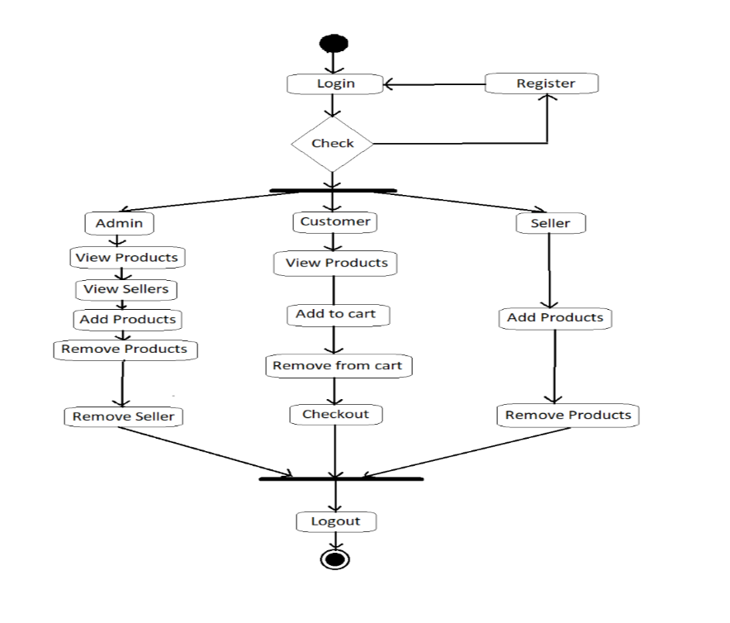

**Data-Flow Diagrams**

**DFD Level 0:**

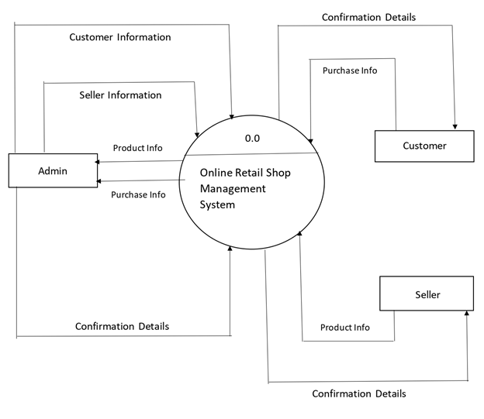

**DFD Level 1:** 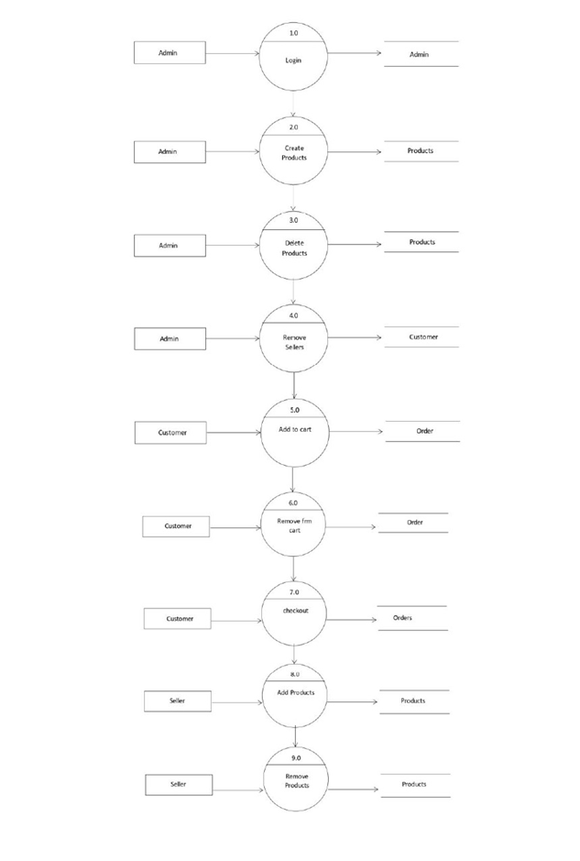

**Data Model**

*Collection Name: orders*

| Field Type | DataType | Description |
| --- | --- | --- |
| o_id | object | Unique, pk auto-generated by mongo |
| orderItems | array | required |
| shippingAddress | object | required |
| paymentMethod | string | required |
| itemsPrice | number | required |
| shippingPrice | number | required |
| taxPrice | number | required |
| totalPrice | number | required |
| user | object | required, fk of user collection |
| isPaid | boolean | Payment status |
| isDelivered | boolean | Delivery status |
| createdAt | date | Timestamp generated by mongo |
| updatedAt | date | Timestamp generated by mongo |
| paidAt | date | Payment Timestamp |
| deliveredAt | date | Delivery Timestamp |
| paymentResult | string | Payment status (success or failure) |

*Collection Name: products*

| Field Type | DataType | Description |
| --- | --- | --- |
| pr_id | object | Unique, pk auto-generated by mongo |
| name | string | required, unique |
| slug | string | required, unique |
| image | string | required |
| images | string | required |
| brand | string | required |
| category | string | required |
| description | string | required |
| price | number | required |
| countInStock | number | required |
| rating | number | required |
| numReviews | number | required |
| reviews | object | required |
| createdAt | date | Timestamp generated by mongo |
| updatedAt | date | Timestamp generated by mongo |

*Collection Name: reviews*

| Field Type | DataType | Description |
| --- | --- | --- |
| r_id | object | Unique, pk auto-generated by mongo |
| name | string | required |
| comment | string | required |
| rating | string | required |
| createdAt | date | Timestamp generated by mongo |
| updatedAt | date | Timestamp generated by mongo |

*Collection Name: users*

| Field Type | DataType | Description |
| --- | --- | --- |
| u_id | object | Unique, pk auto-generated by mongo |
| name | string | required |
| email | string | required |
| password | string | required, stored using JWT tokens  for security purposes |
| isAdmin | boolean | required |
| createdAt | date | Timestamp generated by mongo |
| updatedAt | date | Timestamp generated by mongo |

*Collection Name: payments*

| Field Type | DataType | Description |
| --- | --- | --- |
| p_id | object | Unique, pk auto-generated by mongo |
| order_id | string | required |
| name | string | required |
| status | string | required |
| createdAt | date | Timestamp generated by mongo |
| updatedAt | date | Timestamp generated by mongo |

**User Interfaces**

**1. Home Page**

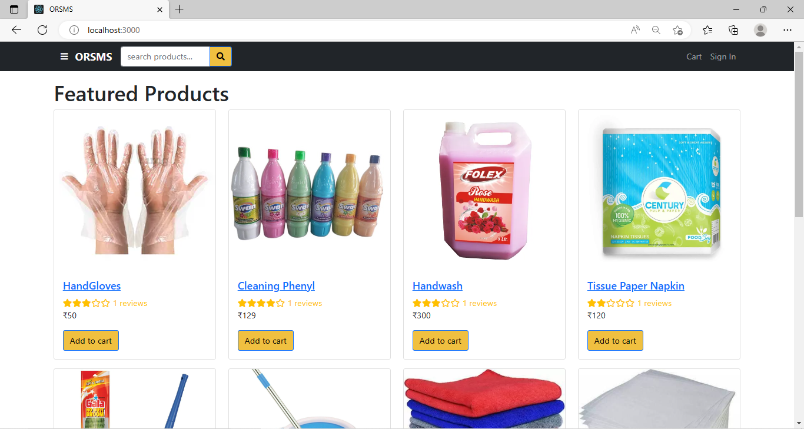

**2. Signup Page**

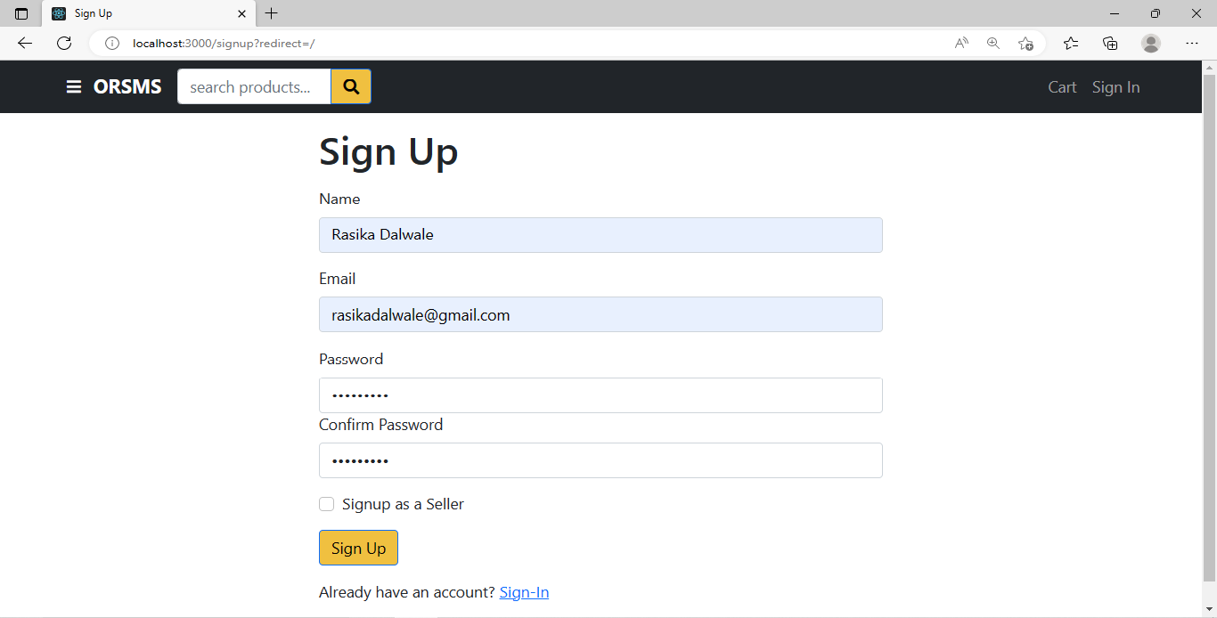

**3. Signin Page**

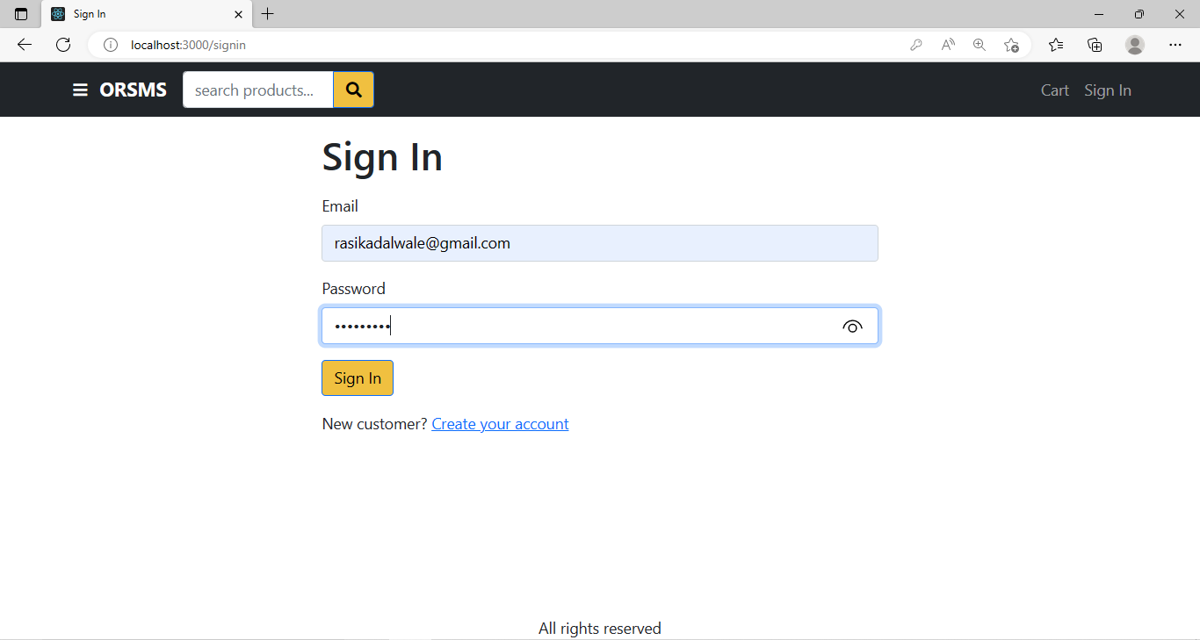

**4. Customer Login**

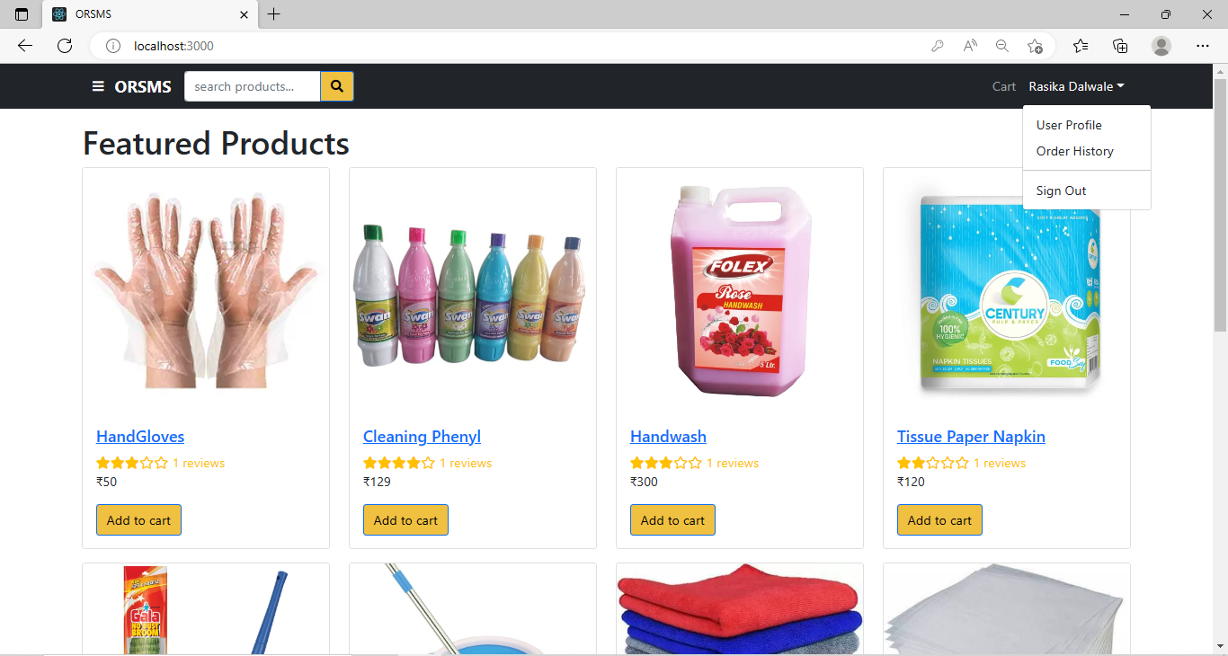

**5. Admin Login**

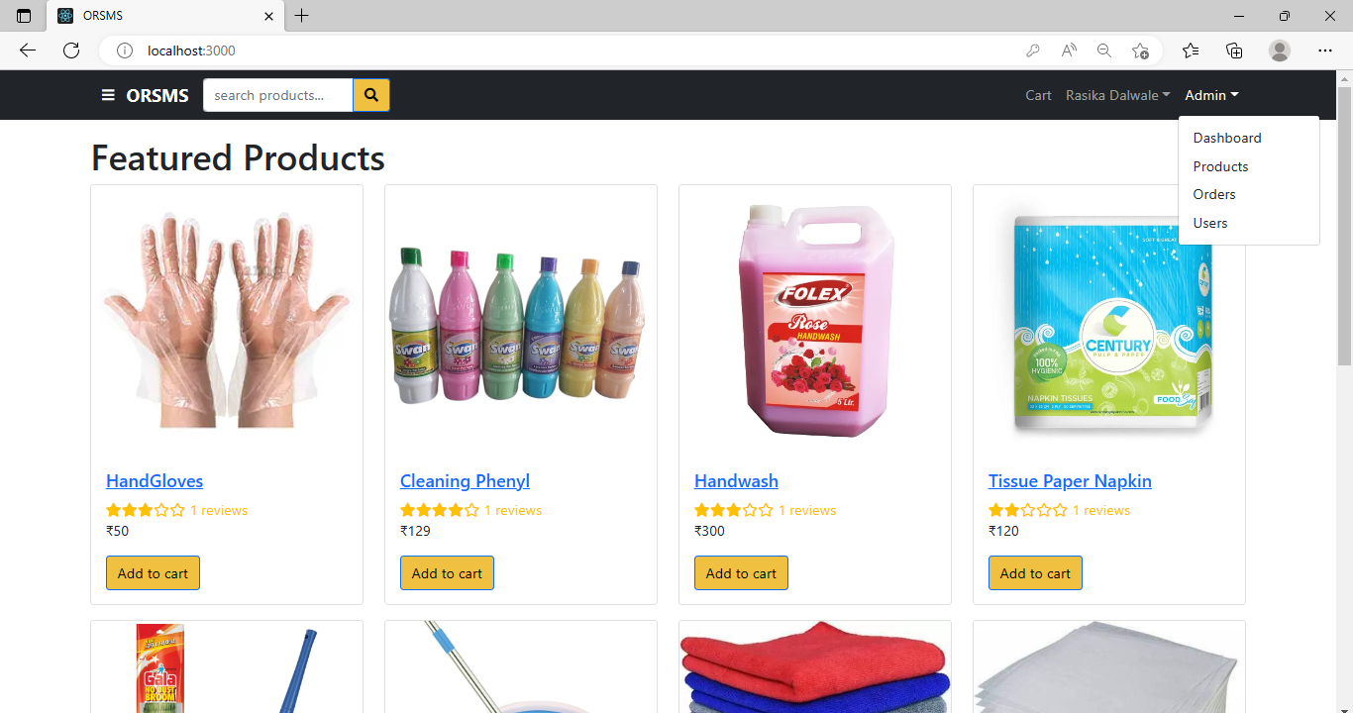

**6. Product Details**

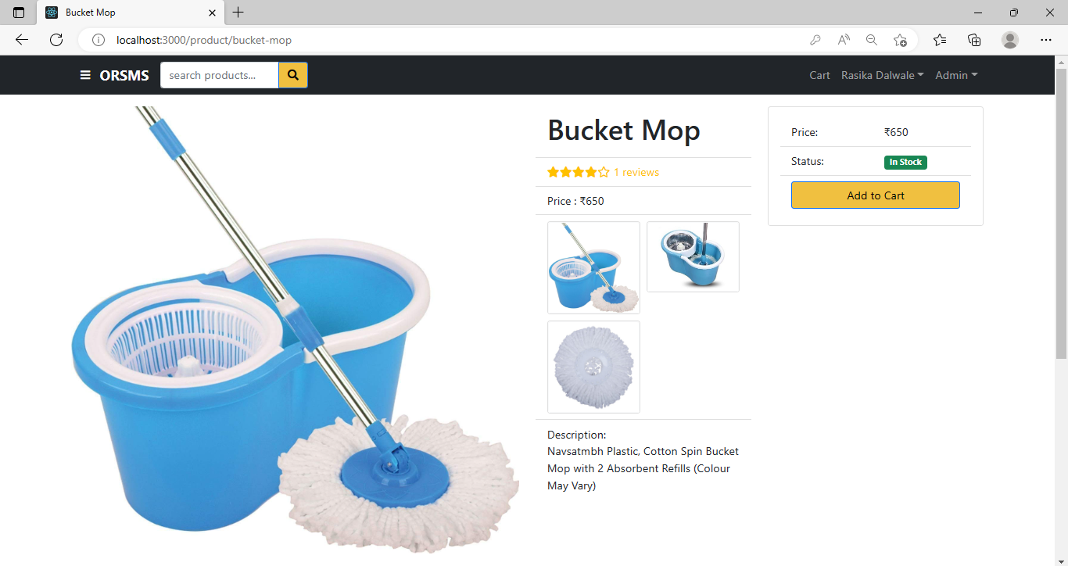

**7. Shipping Page**

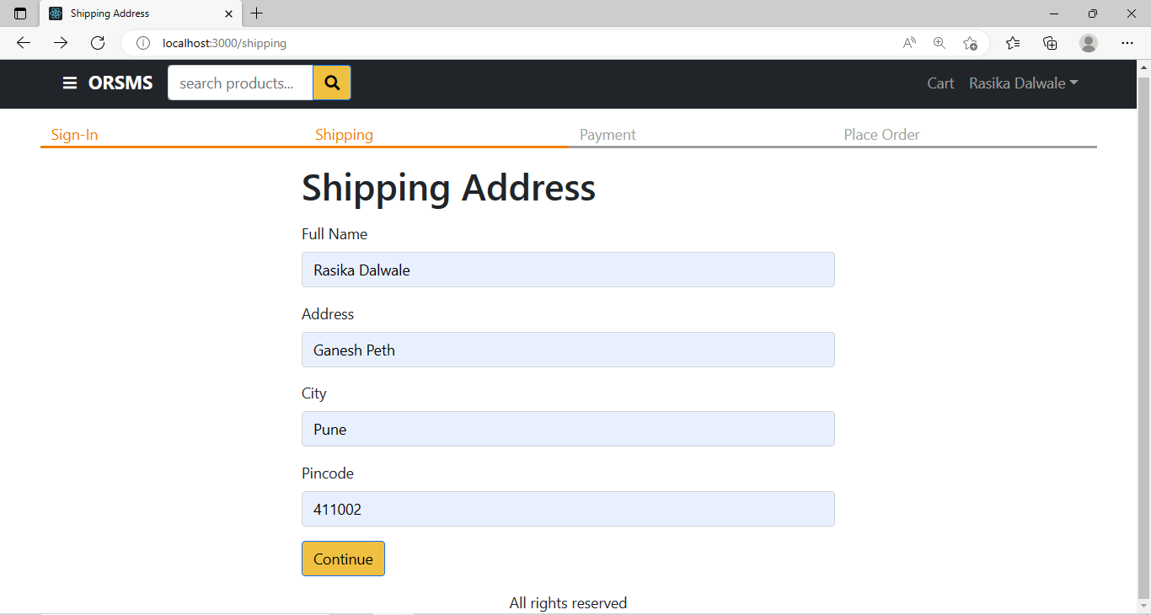

**8. Order Details Page**

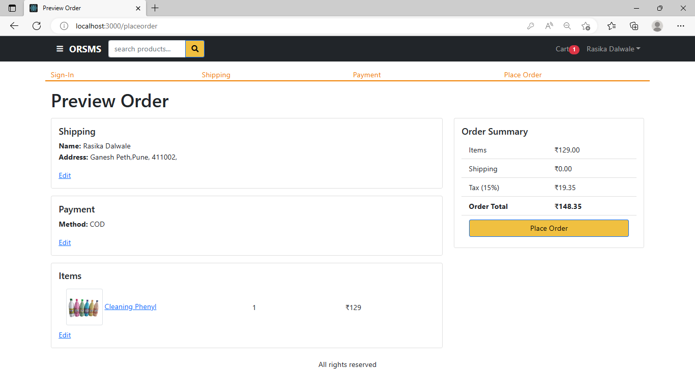

**9. Order Confirmation Page**

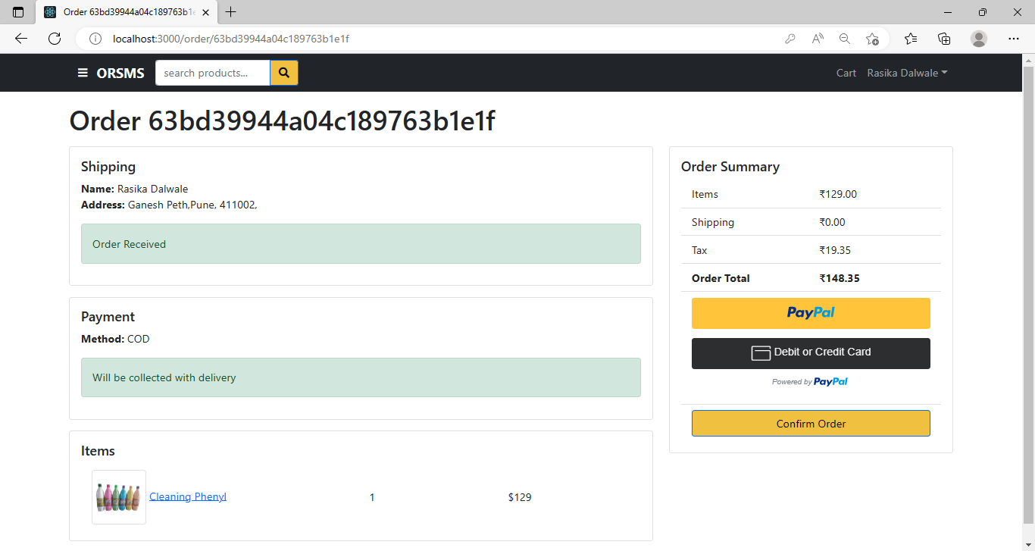

**10. Order History Page**

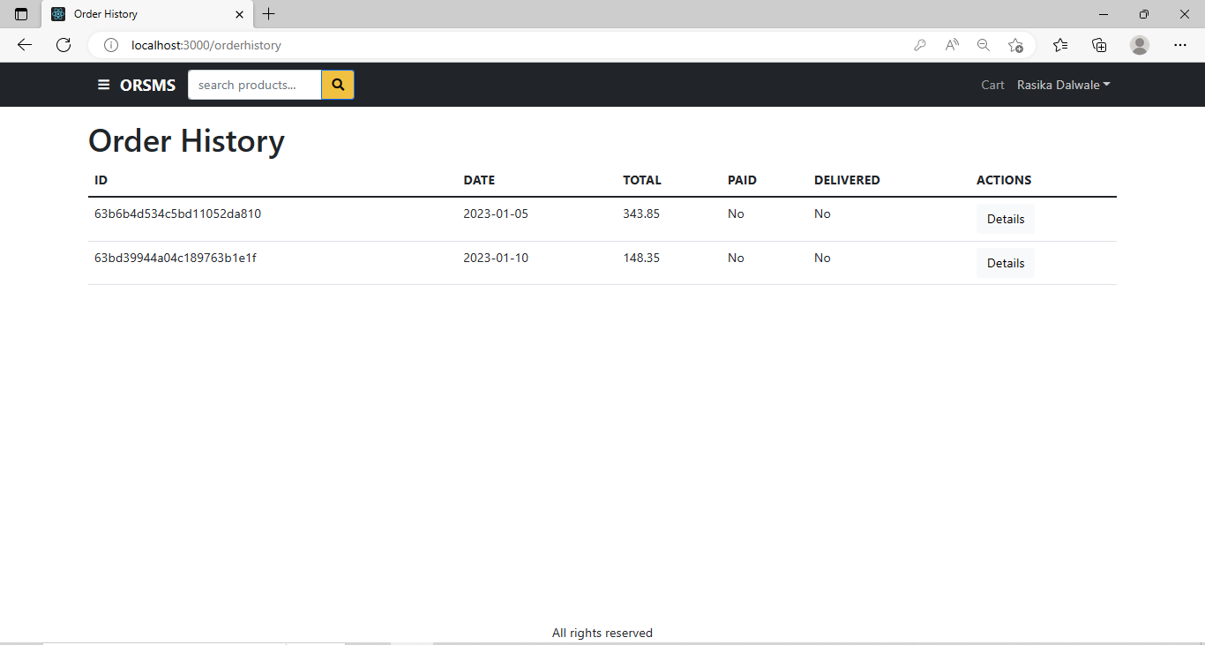

**11. Search or Filter Products**

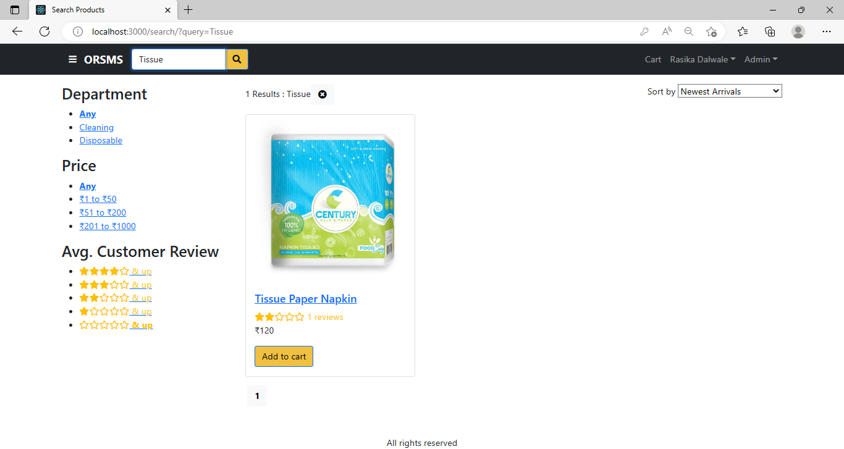

**12. Cart Page**

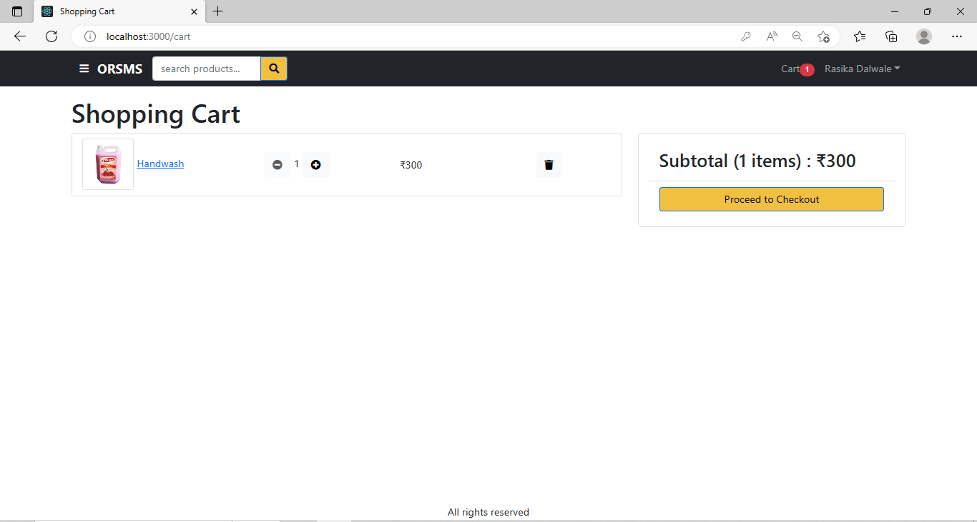

**13. Cart Page Dynamically Add Products**

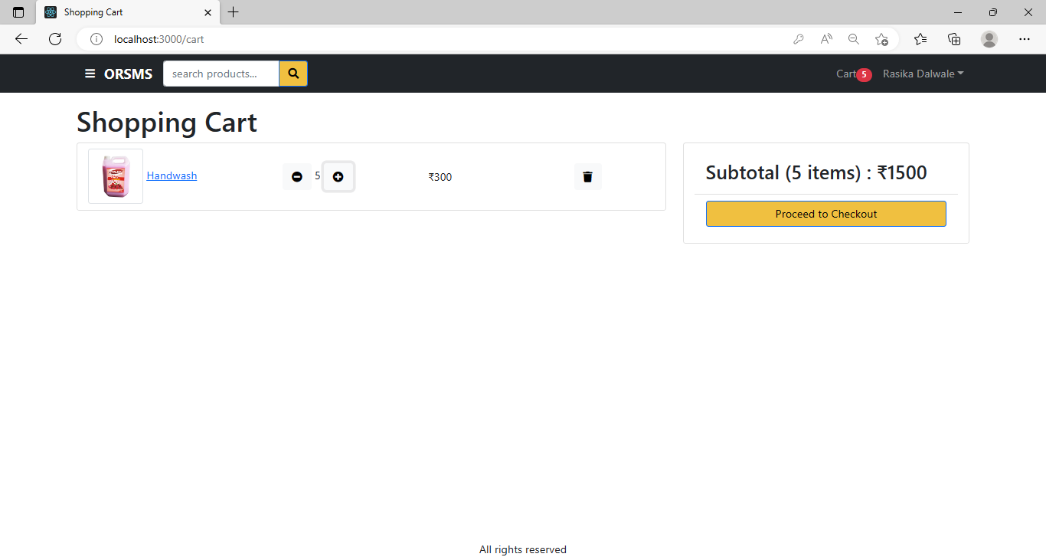

**14. Create Product**

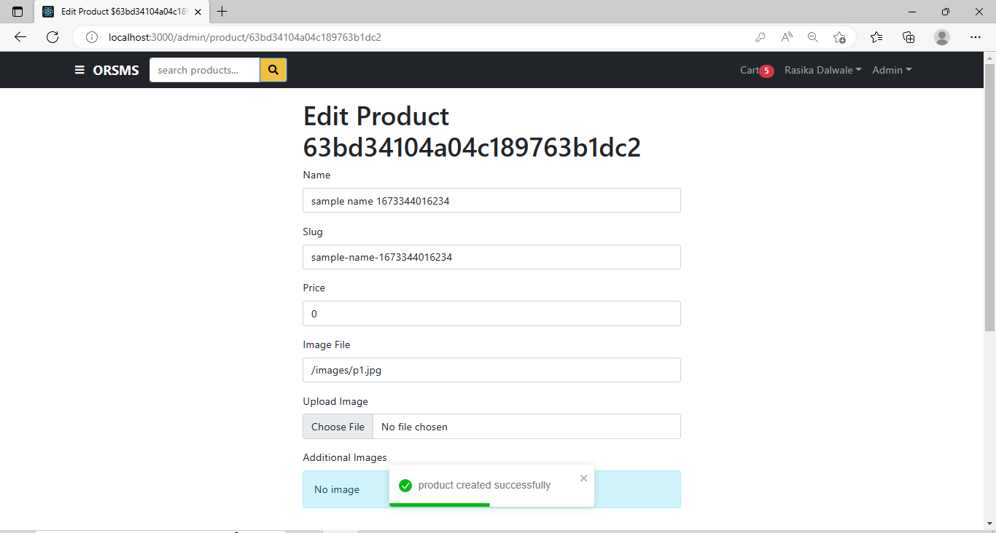

**15. Edit Product**

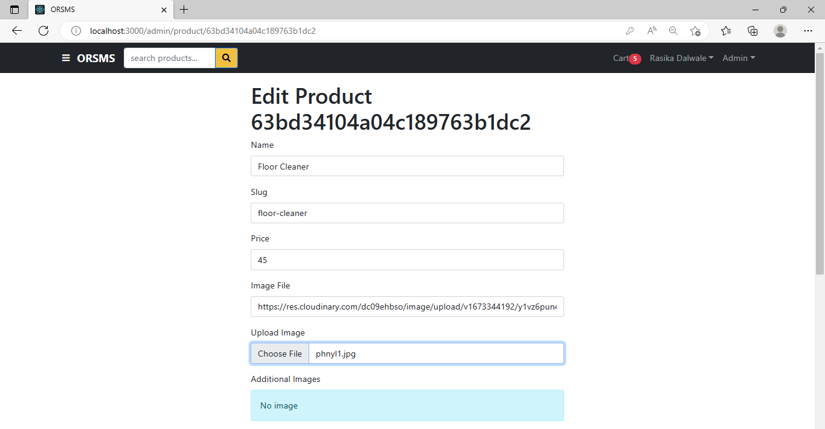

**16. Order List Page - Admin Login**

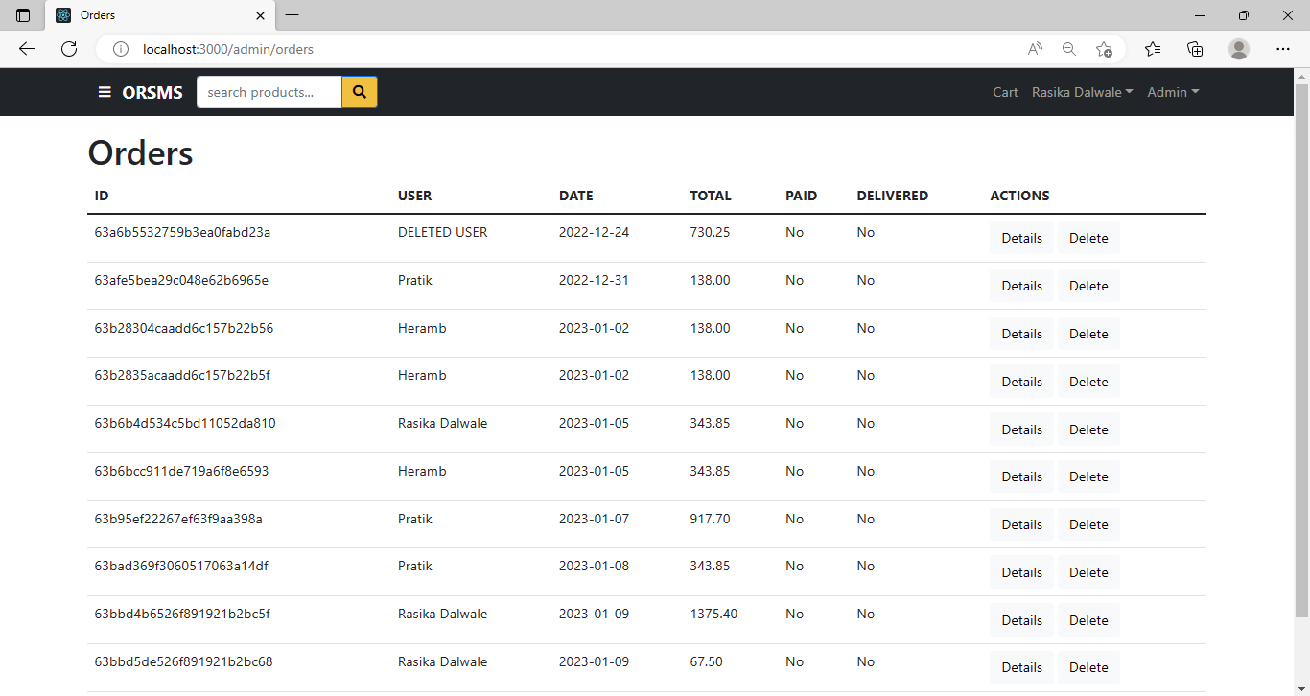

**17. Users List Page - Admin Login**

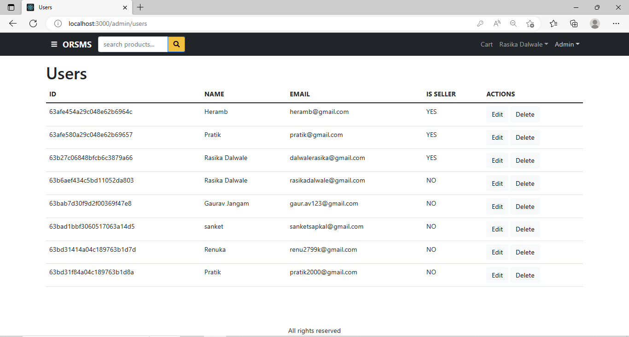

**18. Product List - Admin Login**

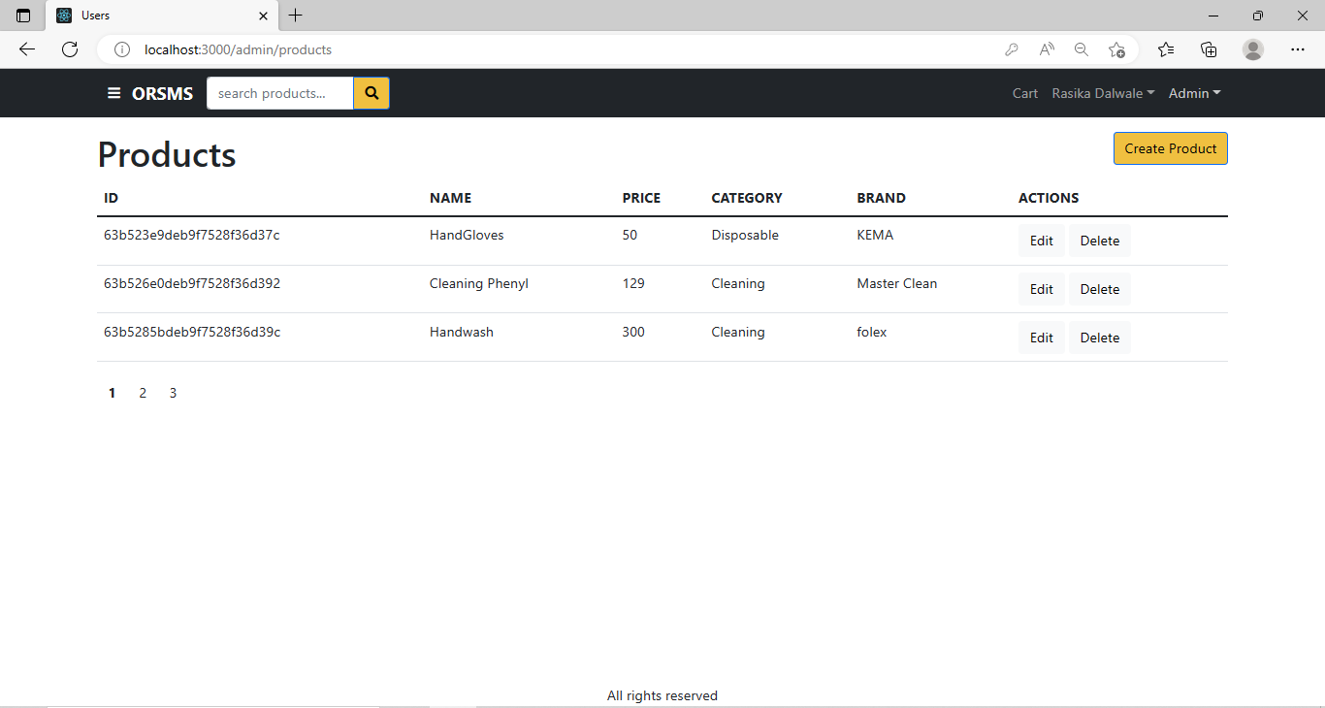

**19. Admin Dashboard For Sales - Admin Login**

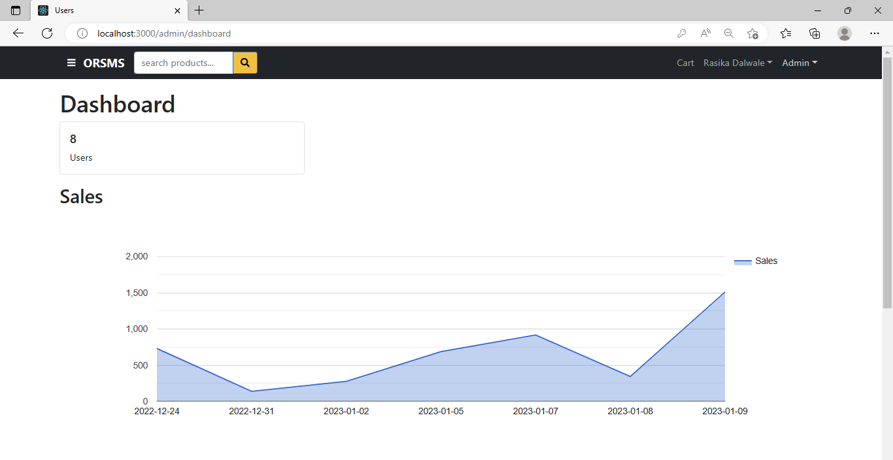

**20. Admin Dashboard For Product Categories - Admin Login**

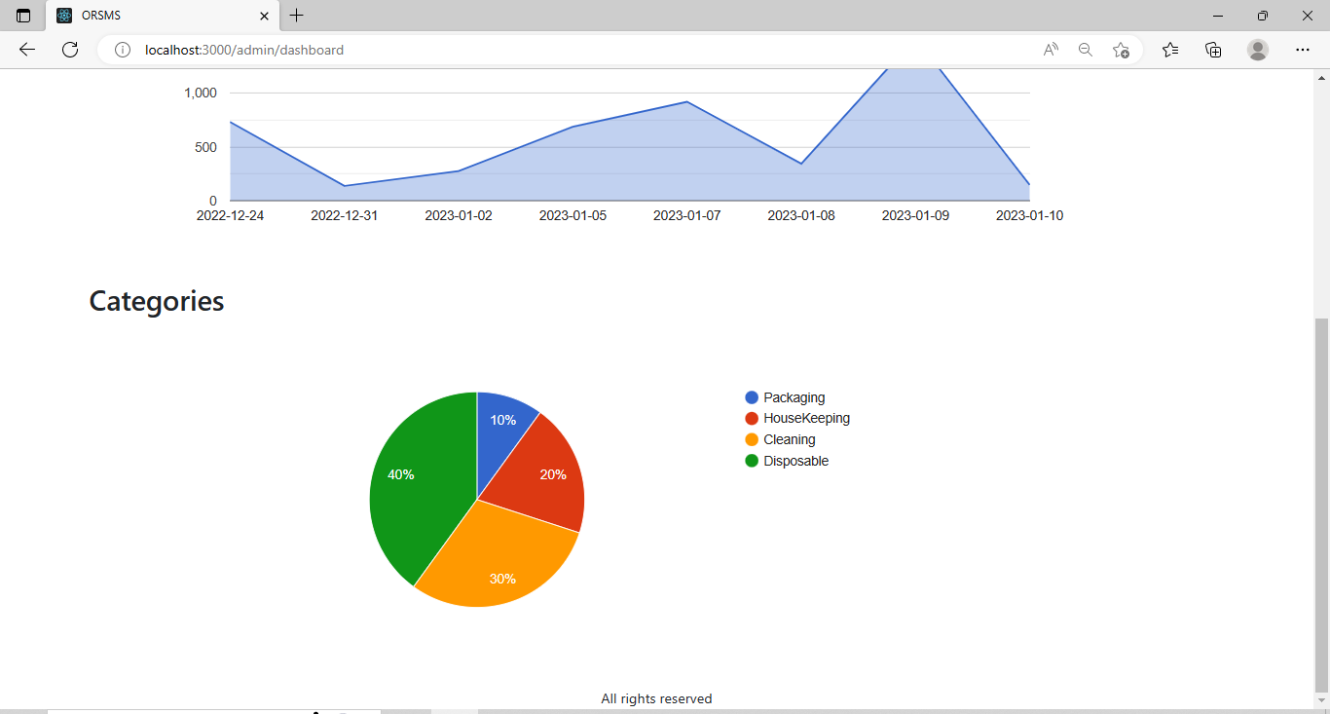

**Testing Methods Used**

Testing is the process of evaluating a system or its component(s) with the intent to find whether it satisfies the specified requirements or not. Testing is executing a system in order to identify any gaps, errors, or missing requirements in contrary to the actual requirements. Using the test data, following test run are carried out:

1. Unit Test
2. System Test

Unit Test:

Unit testing is a level of software testing where individual units/components of software are tested. The purpose of this test is to validate that each unit of the software performs as designed. A unit is the smallest testable part of any software. It usually has one or a few inputs and usually a single output.

System Test:

System Testing is a level of software testing where complete and integrated software is tested. The purpose of this test is to evaluate the system’s compliance with the specified requirements. Usually, Black Box Testing method is used. In System Testing, the functions of the systems are tested from an end-to-end perspective. System Testing is usually carried out by a team that is independent of the development team in order to measure the quality of the system unbiased.

**Conclusion And Recommendations**

* ORSMS is designed for better experience & to avail an ‘Ease of Doing Business’ to user. No need to download it manually though anonymous websites. This platform can be feasible for any person who does job or business full day. This platform is also useful for MSMEs, startups, etc.
* Security is maintained as the complete regional control of the system is maintained so that no malware can affect any one of the users’ Mobile or Computers. This platform will help publisher to avoid misuse of their products and data corruption.
* Additionally, this platform will produce many job opportunities, as it will need huge manpower for delivering & tracking products, business and commerce-related operations, etc.

**Future Enhancements**

* This System being web-based and an undertaking of the Cyber Security Division, needs to be thoroughly tested to find out any security gaps.
* Multiple payment options including Unified Payments’ Interface (UPI), Net Banking, etc. can be provided in more efficient and secure way.
* An order can be tracked more efficiently and real-time using an independent platform that handles order delivery for this platform.
* It is possible to show sales data, that is to show item-wise, category-wise and month-wise sales to seller, in order to increase the analytical ability of the sales.

**Bibliography**

* Software Engineering
* HTML & Web Designing
* Fundamentals of web development by RANDY CONNOLLY AND RICARDO HOAR

**ONLINE REFERENCES:**

* [https://www.w3schools.com](https://www.w3schools.com/)
* [https://developer.mozilla.org](https://developer.mozilla.org/)
* [https://github.com](https://github.com/)